**Moulik Tammana**

**Q8. You have a Cisco switch and a VoIP phone that needs to be placed in a voice VLAN (VLAN 20). The data for the PC should remain in a separate VLAN (VLAN 10). Configure the switch port to support both voice and data traffic.**

**This is the overall network that is created. We have configured VLAN 10 for data traffic and VLAN 20 for voice traffic.**

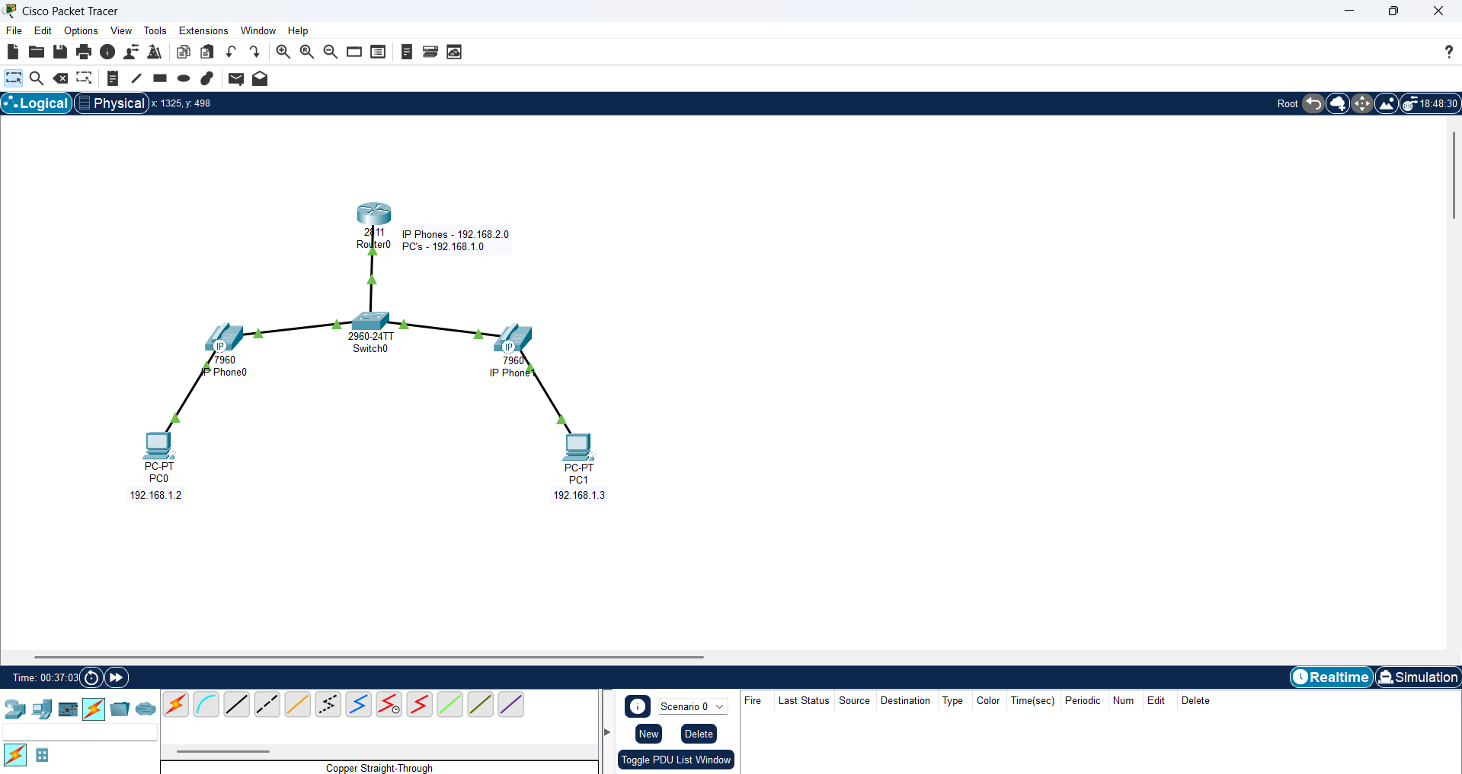

**Switch Configuration:**

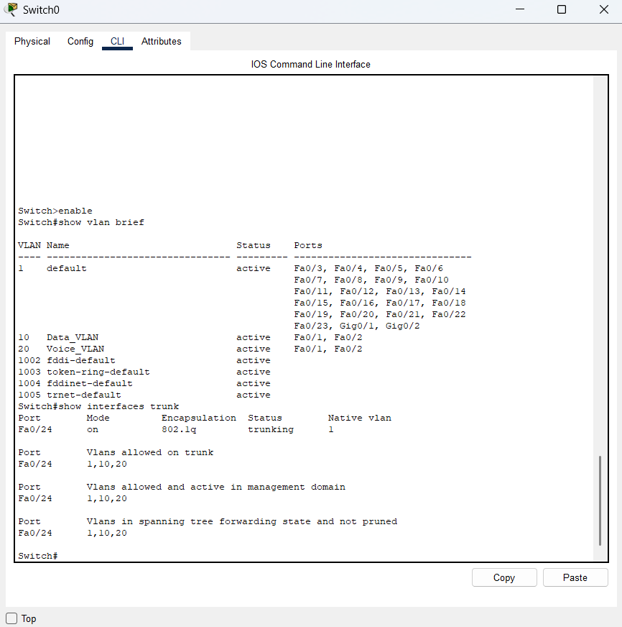

**IP phone Configuration:**

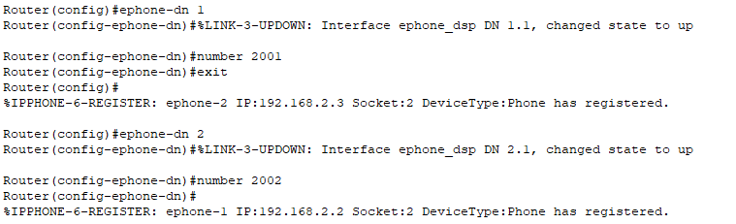

**We can observe that for pinging between the PC’s the packet is not going to the router but for pinging a IP Phone from a PC, the packet is travelling to the router, this shows that separate VLAN’s we configured for data and voice traffic.**

**PC0 to PC1:**

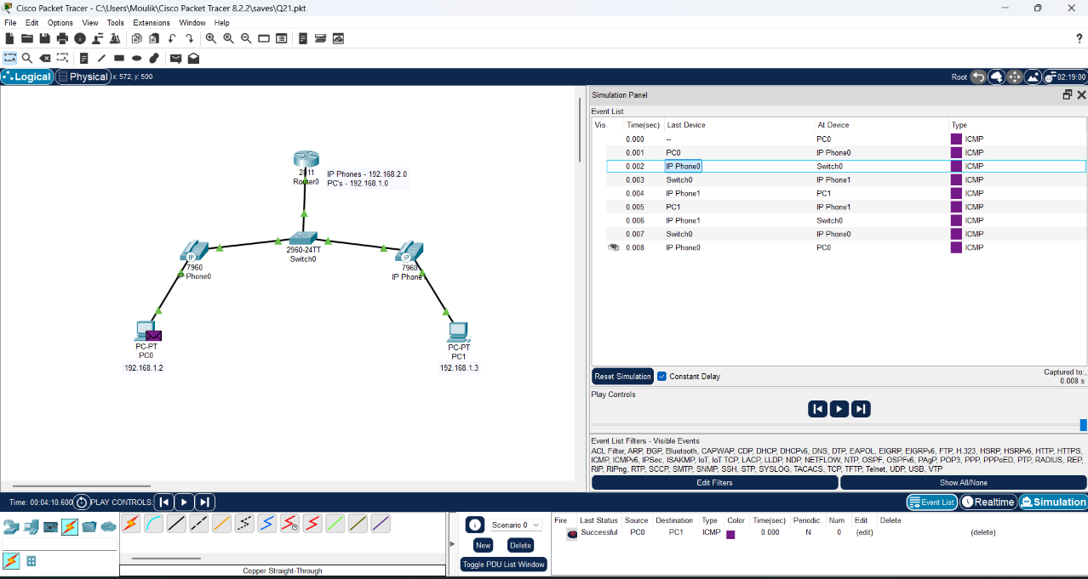

**PC0 to IP Phone 1:**



